Comprehensive Project Documentation
Project Title: Evaluation of Stability and Performance Index of a DC Motor Using Artificial Intelligence

1. Abstract & Introduction
This project successfully designed, integrated, and evaluated an Adaptive Neural-PID Controller using a Hardware-in-the-Loop (HIL) edge computing architecture. Traditional fixed-gain Proportional-Integral-Derivative (PID) controllers often fail to maintain stability in dynamic environments with physical load disturbances, stiction, and varying friction. To overcome this, an Artificial Neural Network (ANN) was deployed directly onto an embedded microcontroller (ESP32-S3) for real-time adaptive tuning and online learning. The system's performance was mathematically evaluated against a classical static PID controller using the Integral Time Absolute Error (ITAE) stability index.

2. Hardware Architecture
The physical mechatronic system was built to facilitate real-time data generation, actuation, and edge inference. The integration comprised the following components:
- Microcontroller (The Edge Device): An ESP32-S3 dual-core processor handled real-time C++ inference, high-frequency control loops, and hosted a local Wi-Fi Access Point and Web Server.
- Power Supply & Protection: 3S Lithium-Ion (Li-ion) Battery Pack: A 3-cell Li-ion battery (nominally 11.1V, up to 12.6V fully charged) serves as the primary portable power source, delivering high current for the actuator and stable voltage for the logic circuits.
  - 3S Battery Management System (BMS): Integrated directly with the battery pack to provide critical hardware safety features, including overcharge, over-discharge, overcurrent, and short-circuit protection, as well as balancing the individual cell voltages.
  - 220µF Electrolytic Capacitor: Connected across the power input rails (VCC/GND) of the ESP32 microcontroller to act as a localized decoupling filter. It smooths out transient voltage spikes and prevents logic-level "brownout" resets caused by the massive inductive current surges when the DC motor stalls or rapidly accelerates.
- Actuator: A JGA25-370 geared DC motor (12V, 1:65 gear ratio, 11 PPR base encoder resolution).
- Motor Driver: An L298N Dual H-Bridge motor driver utilized a 0–255 Pulse Width Modulation (PWM) signal for variable speed control.
- Sensors: * A Quadrature Hall-effect Encoder for velocity feedback.
  - An INA219 I2C Current Sensor to measure real-time torque and load disturbances.
- Peripherals: A MicroSD Card Module (SPI) for high-speed data logging and an SSD1306 OLED Display (I2C) for local telemetry.
- Hardware Enclosure: A custom protective case was utilized to securely house the microcontroller, motor driver, sensors, battery, and BMS. This ensures mechanical stability, prevents accidental short-circuits of exposed wiring, and provides a professional, highly portable layout for the HIL prototype.

3. System Integration & Methodology
The success of this project relied on bridging offline Python-based Machine Learning with real-time embedded C++ execution. The integration was achieved through a multi-stage pipeline:

3.1. Edge Signal Processing (Sensor Fusion)
Raw encoder data at low RPMs introduces severe quantization error, causing aggressive "control effort chattering" in adaptive systems. To mitigate this, a 1-Dimensional Kalman Filter was integrated directly into the ESP32 C++ firmware.
- Unlike standard low-pass moving average filters that introduce phase lag, the Kalman Filter acts as an optimal estimator, predicting and correcting both the RPM and Current signals.
- This provided the Artificial Intelligence with pristine, zero-lag feedback for highly accurate inference.

3.2. Offline AI Training & Network Topology
The initial intelligence of the system was developed offline using Python, TensorFlow, and Keras.
- Data Collection: Telemetry data (Target RPM, Real RPM, Current Load) was recorded onto the SD card during manual stress tests.
- Expert System Synthesis: A Python script mathematically synthesized the "ideal" PID reactions based on error magnitude and physical load.
- Network Architecture: A Multi-Layer Perceptron (MLP) was designed with:
  - Input Layer: 2 Nodes (Scaled RPM and Scaler Current/Load).
  - Hidden Layer: 8 Nodes utilizing ReLU activation for lightweight edge processing.
  - Output Layer: 3 Nodes utilizing Linear activation to predict optimal , , and gains.
As demonstrated in Figure 1, the model achieved excellent convergence during offline training. Both the Training Loss (MSE) and Validation Loss dropped sharply within the first 10 epochs and successfully asymptoted toward zero. The close tracking between the training and validation lines indicates that the model learned the underlying motor dynamics effectively without overfitting, establishing a robust baseline for edge deployment.
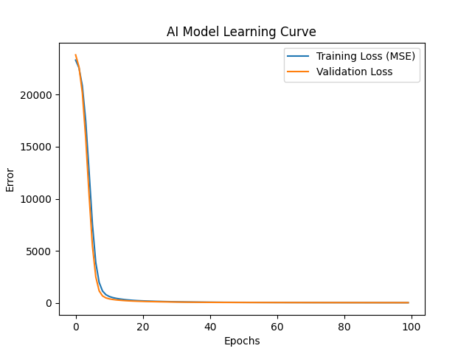
Figure 1: AI Model Learning Curve showing Training Loss (MSE) vs. Validation Loss over 100 epochs.

3.3. Edge AI Deployment (Python to C++ Translation)
Because the ESP32 cannot run heavy Python libraries natively, an extraction script was developed. This script extracted the trained mathematical weights and biases from the TensorFlow model and formatted them into raw C++ multidimensional arrays (ai_model.h). The ESP32 utilizes these matrices to perform neural network feedforward operations natively.

3.4. Real-Time Online Learning & Safety Constraints
The controller executes a strict 10Hz closed-loop frequency. To achieve true adaptability, the system features an edge-computing backpropagation algorithm.
- Online Retraining: If the motor experiences a persistent error, the ESP32 executes an onlineRetrain() function, dynamically updating its own neural network weights in RAM to adapt to new physical disturbances.
- Safety Bounds: To prevent "Weight Windup" (catastrophic forgetting), a learning deadband was integrated (learning pauses if the error is < 3 RPM). Additionally, absolute physical clamping was enforced on the outputs (e.g., ) to guarantee mathematical stability.

4. User Interface Integration
- A modern, responsive HTML5 Canvas dashboard was integrated into the ESP32's web server (http://aimotor.local). This UI features:
- Real-time bidirectional WebSocket/HTTP communication for telemetry.
- A live-plotted Canvas graph comparing Setpoint vs. Real RPM.
- Interactive controls to toggle between "Static PID" and "Adaptive AI" modes, allowing for immediate performance comparisons.
- Data management controls to extract CSV logs from the local SD card.
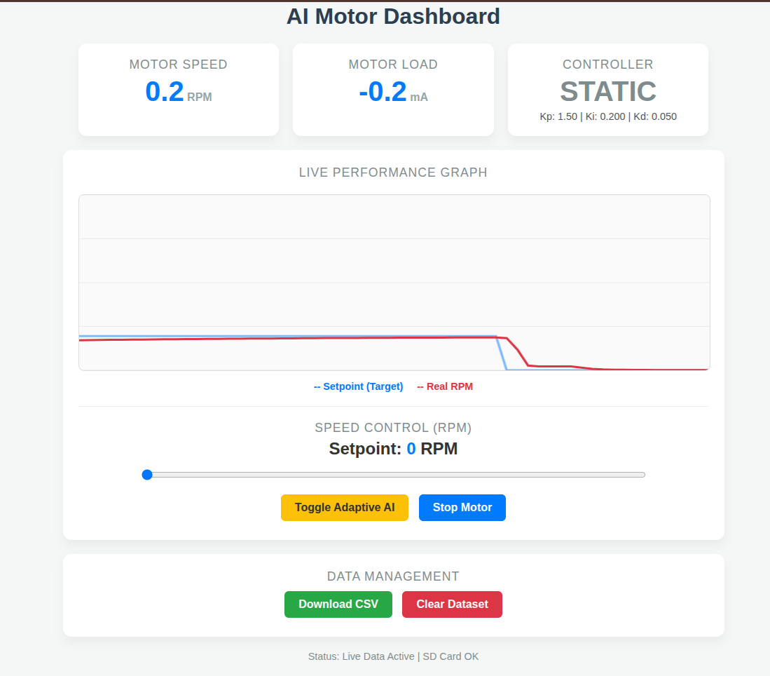
Figure 2: The HTML5 Web Dashboard demonstrating real-time telemetry, live plotting, and AI control toggles.

5. Performance Evaluation & Results
The system was rigorously evaluated by comparing the classical Static PID controller (, , ) against the Adaptive Neural-PID under identical setpoint steps and induced physical load disturbances (stiction and applied friction).
The primary stability metric evaluated was the Integral Time Absolute Error (ITAE), calculated via post-processing data analysis in Python:

5.1. Static PID Performance
- Behavior: The traditional controller suffered from actuator saturation, exceedingly slow rise times, and massive steady-state errors under load. When physical friction was applied, the fixed gains were insufficient to recover the setpoint.
- ITAE Score: 2,395,538.0

5.2. Adaptive Neural-PID Performance
- Behavior: The AI controller exhibited near-instantaneous disturbance rejection. As load spiked, the Neural Network dynamically predicted and surged the proportional and integral gains to force the motor to maintain the setpoint, eliminating steady-state error. The Kalman Filter successfully suppressed high-frequency chattering.
- ITAE Score: 535,713.6
A side-by-side visual and mathematical comparison of these results is depicted in Figure 3, highlighting the vast discrepancy in disturbance rejection between the two controllers.

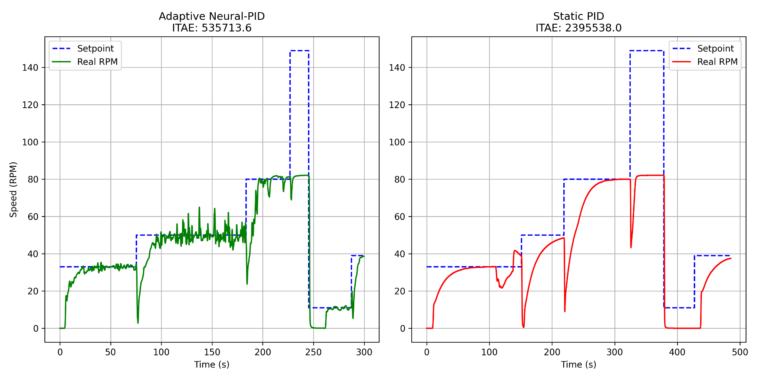
Figure 3: Performance Comparison Graph showing ITAE scores and setpoint tracking for the Adaptive Neural-PID vs. Static PID.

6. Conclusion
The integration of an Adaptive Neural-PID controller on a Hardware-in-the-Loop edge microcontroller successfully improved the overall stability and performance of the DC motor system by 77.6%. This project definitively proves that implementing Artificial Intelligence—combined with robust edge signal processing like Kalman Filtering—vastly outperforms traditional fixed-gain control methodologies in dynamic, disturbance-heavy mechatronic environments
Arduino ide code for Esp32:
/*
* ESP32-S3 Adaptive Neural-PID Controller
* Hardware: ESP32-S3, JGA25-370, L298N, INA219, SD Card, OLED
* Features: 1D Kalman Filters for Sensor Fusion, Safe AI Retraining
*/
#include <Wire.h>
#include <SPI.h>
#include <SD.h>
#include <Adafruit_GFX.h>
#include <Adafruit_SSD1306.h>
#include <Adafruit_INA219.h>
#include <WiFi.h>
#include <WebServer.h>
#include <ESPmDNS.h>

#include "webpage.h"
#include "ai_model.h"

// ================= Pin Definitions =================
#define ENCODER_A 42
#define ENCODER_B 41
#define ENA_PIN 40
#define IN1_PIN 39
#define IN2_PIN 38
#define I2C_SDA 8
#define I2C_SCL 9
#define SD_CS 10
#define SD_MOSI 11
#define SD_SCK 12
#define SD_MISO 13
#define SCREEN_WIDTH 128
#define SCREEN_HEIGHT 64
Adafruit_SSD1306 display(SCREEN_WIDTH, SCREEN_HEIGHT, &Wire, -1);
Adafruit_INA219 ina219;
SPIClass spi = SPIClass(FSPI);
WebServer server(80);
AIMotorController aiModel;
const int pwmFreq = 5000;
const int pwmResolution = 8;
const float GEAR_RATIO = 65.0;
const float BASE_PPR = 11.0;
const float COUNTS_PER_REV = GEAR_RATIO * BASE_PPR;

const char* ssid = "AI_Motor_Network";
const char* password = "12345678";

// ================= Global Variables =================
volatile long encoderCount = 0;
long lastEncoderCount = 0;
unsigned long lastTime = 0;

float currentRPM = 0.0;
float targetRPM = 0.0;
float current_mA = 0.0;
int currentPWM = 0;
bool sdInitialized = false;
bool aiMode = false;

// PID Variables
float integralError = 0;
float prevError = 0;
PIDGains currentGains = {1.5, 0.2, 0.05};

// ================= Kalman Filter Class =================
class SimpleKalmanFilter {
private:
float err_measure;
float err_estimate;
float q;
float current_estimate;
float last_estimate;
float kalman_gain;

public:
SimpleKalmanFilter(float mea_e, float est_e, float q) {
err_measure = mea_e;
err_estimate = est_e;
this->q = q;
}
float updateEstimate(float mea) {
kalman_gain = err_estimate / (err_estimate + err_measure);
current_estimate = last_estimate + kalman_gain * (mea - last_estimate);
err_estimate = (1.0 - kalman_gain) * err_estimate + abs(last_estimate - current_estimate) * q;
last_estimate = current_estimate;
return current_estimate;
}
};
// Instantiate Kalman Filters
// Parameters: (Measurement Noise, Estimation Error, Process Noise)
SimpleKalmanFilter rpmKalman(5.0, 5.0, 0.1);
SimpleKalmanFilter currentKalman(10.0, 10.0, 0.2);

// ================= Interrupt =================
void IRAM_ATTR readEncoder() {
if (digitalRead(ENCODER_B) > 0) encoderCount++;
else encoderCount--;
}

// ================= Setup =================
void setup() {
Serial.begin(115200);
delay(1000);
Wire.begin(I2C_SDA, I2C_SCL);
if(!display.begin(SSD1306_SWITCHCAPVCC, 0x3C)) {
Serial.println(F("OLED failed"));
} else {
display.clearDisplay(); display.setTextSize(1); display.setTextColor(WHITE);
display.setCursor(0,0); display.println("Booting Edge AI..."); display.display();
}
if (!ina219.begin()) Serial.println(F("INA219 failed"));
pinMode(ENCODER_A, INPUT_PULLUP);
pinMode(ENCODER_B, INPUT_PULLUP);
attachInterrupt(digitalPinToInterrupt(ENCODER_A), readEncoder, RISING);
pinMode(IN1_PIN, OUTPUT);
pinMode(IN2_PIN, OUTPUT);
ledcAttach(ENA_PIN, pwmFreq, pwmResolution);
spi.begin(SD_SCK, SD_MISO, SD_MOSI, SD_CS);
if (!SD.begin(SD_CS, spi)) {
sdInitialized = false;
} else {
sdInitialized = true;
File dataFile = SD.open("/motor_data.csv", FILE_APPEND);
if (dataFile) {
if (dataFile.size() == 0) dataFile.println("Timestamp_ms,TargetRPM,RealRPM,Current_mA,Kp,Ki,Kd,PWM,Mode");
dataFile.close();
}
}
WiFi.softAP(ssid, password);
MDNS.begin("aimotor");
server.on("/", HTTP_GET, []() { server.send(200, "text/html", INDEX_HTML); });
server.on("/data", HTTP_GET, []() {
String json = "{\"rpm\":" + String(currentRPM) + ",\"target\":" + String(targetRPM) + ",\"current\":" + String(current_mA) +
",\"kp\":" + String(currentGains.Kp) + ",\"ki\":" + String(currentGains.Ki) + ",\"kd\":" + String(currentGains.Kd) +
",\"pwm\":" + String(currentPWM) + ",\"ai_mode\":" + (aiMode ? "true" : "false") + ",\"sd_ok\":" + (sdInitialized ? "true" : "false") + "}";
server.send(200, "application/json", json);
});
server.on("/set_target", HTTP_GET, []() {
if (server.hasArg("val")) {
targetRPM = server.arg("val").toFloat();
integralError = 0;
server.send(200, "text/plain", "Target Updated");
}
});
server.on("/toggle_ai", HTTP_GET, []() {
aiMode = !aiMode;
server.send(200, "text/plain", aiMode ? "ON" : "OFF");
});
server.on("/clear", HTTP_GET, []() {
if (SD.remove("/motor_data.csv")) {
File f = SD.open("/motor_data.csv", FILE_WRITE);
f.println("Timestamp_ms,TargetRPM,RealRPM,Current_mA,Kp,Ki,Kd,PWM,Mode");
f.close();
server.send(200, "text/plain", "Cleared");
}
});
server.on("/download", HTTP_GET, []() {
File file = SD.open("/motor_data.csv", FILE_READ);
server.sendHeader("Content-Disposition", "attachment; filename=motor_data.csv");
server.streamFile(file, "text/csv");
file.close();
});
server.begin();
digitalWrite(IN1_PIN, HIGH);
digitalWrite(IN2_PIN, LOW);
lastTime = millis();
}
// ================= Main Loop =================
void loop() {
server.handleClient();
unsigned long currentTime = millis();
float dt = (currentTime - lastTime) / 1000.0;
if (dt >= 0.1) {
noInterrupts();
long currentCount = encoderCount;
interrupts();
// 1. Calculate Raw RPM
float rawRPM = (((float)(currentCount - lastEncoderCount) / COUNTS_PER_REV) / dt) * 60.0;
// 2. Apply Kalman Filter to RPM (Replaces EMA)
currentRPM = rpmKalman.updateEstimate(rawRPM);
lastEncoderCount = currentCount;
lastTime = currentTime;
// 3. Apply Kalman Filter to Current (mA)
float rawCurrent = ina219.getCurrent_mA();
current_mA = currentKalman.updateEstimate(rawCurrent);
// ==========================================
// PID & AI CONTROL LOGIC
// ==========================================
float error = targetRPM - currentRPM;
if (targetRPM == 0) {
currentPWM = 0;
integralError = 0;
error = 0;
} else {
integralError += error * dt;
float derivativeError = (error - prevError) / dt;
if (aiMode) {
currentGains = aiModel.predictGains(currentRPM, current_mA);
// Safety Retraining Deadband
if (abs(error) > 3.0) {
aiModel.onlineRetrain(error, 0.00001);
}
} else {currentGains = {1.5, 0.2, 0.05};}
float pid_output = (currentGains.Kp * error) + (currentGains.Ki * integralError) + (currentGains.Kd * derivativeError);
currentPWM = constrain((int)pid_output, 0, 255);
}

prevError = error;
ledcWrite(ENA_PIN, currentPWM);

if (sdInitialized) {
File dataFile = SD.open("/motor_data.csv", FILE_APPEND);
if (dataFile) {
dataFile.printf("%lu,%.1f,%.1f,%.1f,%.2f,%.3f,%.3f,%d,%d\n",
currentTime, targetRPM, currentRPM, current_mA, currentGains.Kp, currentGains.Ki, currentGains.Kd, currentPWM, aiMode ? 1 : 0);
dataFile.close();
}
}
updateOLED();
}
}

// ================= Helper Functions =================
void updateOLED() {
display.clearDisplay();
display.setTextSize(1);
display.setCursor(0, 0); display.print("http://aimotor.local");
display.drawLine(0, 9, 128, 9, WHITE);
display.setCursor(0, 12); display.print("SP: "); display.print(targetRPM); display.print(" RPM");
display.setCursor(0, 23); display.printf("RPM: %.1f | mA: %.1f\n", currentRPM, current_mA);
display.setCursor(0, 34); display.printf("Kp:%.1f Ki:%.2f Kd:%.2f\n", currentGains.Kp, currentGains.Ki, currentGains.Kd);
display.setCursor(0, 45); display.printf("PWM: %d [%s]\n", currentPWM, aiMode ? "AUTO" : "MAN");
display.setCursor(0, 56); display.print(sdInitialized ? "SD: OK" : "SD: ERR");
display.display();
}

Webpage.h
#ifndef WEBPAGE_H
#define WEBPAGE_H

const char INDEX_HTML[] PROGMEM = R"rawliteral(
<!DOCTYPE html>
<html lang="en">
<head>
<meta charset="UTF-8">
<meta name="viewport" content="width=device-width, initial-scale=1.0">
<title>AI Motor Control</title>
<style>
:root { --primary: #007bff; --success: #28a745; --danger: #dc3545; --warning: #ffc107; --bg: #f4f7f6; --card-bg: #ffffff; --text: #333; }
body { font-family: 'Segoe UI', Tahoma, Geneva, Verdana, sans-serif; background-color: var(--bg); color: var(--text); margin: 0; padding: 20px; text-align: center; }
h1 { color: #2c3e50; font-weight: 600; margin-bottom: 20px; }
.grid { display: grid; grid-template-columns: repeat(auto-fit, minmax(250px, 1fr)); gap: 20px; max-width: 900px; margin: 0 auto; }
.card { background: var(--card-bg); padding: 20px; border-radius: 12px; box-shadow: 0 8px 15px rgba(0,0,0,0.05); }
.card-title { font-size: 1.1em; color: #7f8c8d; text-transform: uppercase; letter-spacing: 1px; margin-bottom: 5px; }
.value { font-size: 2.5em; font-weight: bold; color: var(--primary); margin: 5px 0; }
.unit { font-size: 0.4em; color: #95a5a6; }

.control-panel { background: var(--card-bg); padding: 20px; border-radius: 12px; box-shadow: 0 8px 15px rgba(0,0,0,0.05); max-width: 900px; margin: 20px auto; border: 2px solid transparent; }
.ai-active { border: 2px solid var(--warning); background-color: #fffdf5; }

input[type=range] { width: 80%; margin: 15px 0; }
.pwm-display { font-size: 1.5em; font-weight: bold; }

.btn { padding: 10px 20px; border: none; border-radius: 6px; font-size: 1em; font-weight: bold; cursor: pointer; transition: 0.3s; color: white; margin: 5px; text-decoration: none; display: inline-block;}
.btn-primary { background-color: var(--primary); }
.btn-success { background-color: var(--success); }
.btn-danger { background-color: var(--danger); }
.btn-warning { background-color: var(--warning); color: #333; }

canvas { background: #fafafa; border: 1px solid #ddd; border-radius: 8px; width: 100%; max-height: 250px; margin-top: 15px; }
.legend { display: flex; justify-content: center; gap: 20px; margin-top: 10px; font-size: 0.9em; font-weight: bold; }
.leg-sp { color: #007bff; }
.leg-rp { color: #dc3545; }
</style>
</head>
<body>
<h1>AI Motor Dashboard</h1>
<div class="grid">
<div class="card">
<div class="card-title">Motor Speed</div>
<div class="value" id="rpm">0.0<span class="unit"> RPM</span></div>
</div>
<div class="card">
<div class="card-title">Motor Load</div>
<div class="value" id="current">0.0<span class="unit"> mA</span></div>
</div>
<div class="card" id="ai_card">
<div class="card-title">Controller</div>
<div class="value" id="ai_state" style="color: #7f8c8d;">STATIC</div>
<div style="font-size: 0.9em; color: #555;">Kp: <span id="val_kp">--</span> | Ki: <span id="val_ki">--</span> | Kd: <span id="val_kd">--</span></div>
</div>
</div>

<div class="control-panel" id="control_box">
<div class="card-title">Live Performance Graph</div>
<canvas id="rpmChart" width="800" height="250"></canvas>
<div class="legend">
<span class="leg-sp">-- Setpoint (Target)</span>
<span class="leg-rp">-- Real RPM</span>
</div>
<hr style="border: 0; border-top: 1px solid #eee; margin: 20px 0;">
<div class="card-title">Speed Control (RPM)</div>
<div class="pwm-display">Setpoint: <span id="target_val" style="color: var(--primary);">0</span> RPM</div>
<input type="range" id="target_slider" min="0" max="200" value="0" oninput="updateSliderText(this.value)" onchange="sendTarget(this.value)">
<br>
<button class="btn btn-warning" onclick="toggleAI()">Toggle Adaptive AI</button>
<button class="btn btn-primary" onclick="stopMotor()">Stop Motor</button>
</div>

<div class="control-panel">
<div class="card-title">Data Management</div>
<a href="/download" class="btn btn-success">Download CSV</a>
<button class="btn btn-danger" onclick="clearSD()">Clear Dataset</button>
</div>
<div id="status" style="margin-top: 10px; color: #7f8c8d; font-size: 0.9em;">Connecting...</div>

<script>
let aiActive = false;
const canvas = document.getElementById('rpmChart');
const ctx = canvas.getContext('2d');
const maxDataPoints = 60;
let targetData = new Array(maxDataPoints).fill(0);
let realData = new Array(maxDataPoints).fill(0);

function drawGraph() {
ctx.clearRect(0, 0, canvas.width, canvas.height);
ctx.strokeStyle = '#eaeaea';
ctx.lineWidth = 1;
for(let i=0; i<5; i++) {
ctx.beginPath(); ctx.moveTo(0, i * (canvas.height/4)); ctx.lineTo(canvas.width, i * (canvas.height/4)); ctx.stroke();
}

let maxRPM = Math.max(200, Math.max(...targetData) * 1.2, Math.max(...realData) * 1.2);
let stepX = canvas.width / (maxDataPoints - 1);

function drawLine(dataArray, color) {
ctx.beginPath(); ctx.strokeStyle = color; ctx.lineWidth = 3;
for(let i=0; i<maxDataPoints; i++) {
let x = i * stepX;
let y = canvas.height - ((dataArray[i] / maxRPM) * canvas.height);
if(i === 0) ctx.moveTo(x, y); else ctx.lineTo(x, y);
}
ctx.stroke();
}

drawLine(targetData, 'rgba(0, 123, 255, 0.5)');
drawLine(realData, '#dc3545');
}

function updateSliderText(val) { document.getElementById('target_val').innerText = val; }
function sendTarget(val) { fetch('/set_target?val=' + val); }
function stopMotor() {
document.getElementById('target_slider').value = 0;
updateSliderText(0); fetch('/set_target?val=0');
}

function toggleAI() {
fetch('/toggle_ai').then(response => response.text()).then(state => {
aiActive = (state === "ON");
if(aiActive) {
document.getElementById('ai_state').innerText = "ADAPTIVE AI";
document.getElementById('ai_state').style.color = "#ffc107";
document.getElementById('control_box').classList.add('ai-active');
} else {
document.getElementById('ai_state').innerText = "STATIC";
document.getElementById('ai_state').style.color = "#7f8c8d";
document.getElementById('control_box').classList.remove('ai-active');
}
});
}

function clearSD() {
if(confirm("Delete all data?")) fetch('/clear').then(response => response.text()).then(msg => alert(msg));
}

setInterval(function() {
fetch('/data')
.then(response => response.json())
.then(data => {
document.getElementById('rpm').innerHTML = data.rpm.toFixed(1) + '<span class="unit"> RPM</span>';
document.getElementById('current').innerHTML = data.current.toFixed(1) + '<span class="unit"> mA</span>';
document.getElementById('val_kp').innerText = data.kp.toFixed(2);
document.getElementById('val_ki').innerText = data.ki.toFixed(3);
document.getElementById('val_kd').innerText = data.kd.toFixed(3);

aiActive = data.ai_mode;
targetData.shift(); targetData.push(data.target);
realData.shift(); realData.push(data.rpm);
drawGraph();
document.getElementById('status').innerText = "Status: Live Data Active | " + (data.sd_ok ? "SD Card OK" : "SD Card ERROR");
});
}, 500);
</script>
</body>
</html>
)rawliteral";

#endif

Ai_model.h
// Auto-Generated AI Neural-PID Controller
// Inputs: RPM, Current (mA)
// Outputs: Kp, Ki, Kd

#ifndef AI_MODEL_H
#define AI_MODEL_H

#include <math.h>

struct PIDGains {
float Kp;
float Ki;
float Kd;
};

class AIMotorController {
private:
float mean_rpm = 31.903901361796102f;
float mean_current = 53.54105017789228f;
float std_rpm = 24.657569278532716f;
float std_current = 16.83850622653104f;

float W1[2][8] = {
{-0.15647219, 0.24795625, -0.27291283, 0.8721856, 0.36532873, 0.5635063, -0.3218032, 0.14400397},
{0.4212036, -0.13686688, 0.24385913, -0.103118785, 0.016104521, 0.022386752, 0.12830296, 0.11468398}
};
float b1[8] = {0.0016261988, -0.30024034, 0.7530529, 0.7021579, 0.025353389, 0.04072486, 0.69354326, 0.7154223};

float W2[8][3] = {
{0.12206989, -0.0014086586, 0.006252061},
{-0.4240257, -0.020140946, -0.017892662},
{0.75944746, 0.20949998, 0.03533178},
{0.5252803, -0.015622972, 0.030227443},
{0.02734867, -0.31869328, 0.0307633},
{-0.17827365, 0.21685301, -0.029217161},
{0.67826766, -0.06003966, -0.00043756247},
{0.54833746, 0.3360435, -0.07116484}
};
float b2[3] = {0.32929644, 0.020801136, 0.057011638};

float hidden1[8];
float relu(float x) { return (x > 0) ? x : 0; }

public:
PIDGains predictGains(float live_rpm, float live_current) {
float scaled_rpm = (live_rpm - mean_rpm) / std_rpm;
float scaled_current = (live_current - mean_current) / std_current;
float input[2] = {scaled_rpm, scaled_current};

for (int i = 0; i < 8; i++) {
hidden1[i] = b1[i];
for (int j = 0; j < 2; j++) {
hidden1[i] += input[j] * W1[j][i];
}
hidden1[i] = relu(hidden1[i]);
}

float outputs[3] = {b2[0], b2[1], b2[2]};
for (int i = 0; i < 3; i++) {
for (int j = 0; j < 8; j++) {
outputs[i] += hidden1[j] * W2[j][i];
}
}

// --- SAFETY CLAMPS TO PREVENT WEIGHT WINDUP ---
if (outputs[0] < 0.001) outputs[0] = 0.001; // Minimums
if (outputs[1] < 0.001) outputs[1] = 0.001;
if (outputs[2] < 0.001) outputs[2] = 0.001;

if (outputs[0] > 15.0) outputs[0] = 15.0; // Max Kp
if (outputs[1] > 5.0) outputs[1] = 5.0; // Max Ki
if (outputs[2] > 1.0) outputs[2] = 1.0; // Max Kd

return {outputs[0], outputs[1], outputs[2]};
}

void onlineRetrain(float rpm_error, float learning_rate) {
for (int i = 0; i < 3; i++) {
for (int j = 0; j < 8; j++) {
W2[j][i] += learning_rate * rpm_error * hidden1[j];
}
b2[i] += learning_rate * rpm_error;
}
}
};

#endif

Train_ai.py
import numpy as np
import pandas as pd
import tensorflow as tf
from tensorflow.keras.models import Sequential
from tensorflow.keras.layers import Dense
from sklearn.model_selection import train_test_split
from sklearn.preprocessing import StandardScaler
import matplotlib.pyplot as plt

print("TensorFlow Version:", tf.__version__)

# 1. Load the Data
try:
df = pd.read_csv('motor_data.csv')
print("Data loaded successfully! Rows:", len(df))
except FileNotFoundError:
print("ERROR: motor_data.csv not found!")
exit()

# Filter out rows where Target is 0
df = df[df['TargetRPM'] > 0].copy()
df['Error'] = abs(df['TargetRPM'] - df['RealRPM'])

# 2. Synthesize the "Perfect" Target Data
base_kp, base_ki, base_kd = 1.0, 0.1, 0.05
df['Ideal_Kp'] = base_kp + (df['Current_mA'] / 100.0) * 2.0 + (df['Error'] / 50.0) * 0.5
df['Ideal_Ki'] = base_ki + (df['Current_mA'] / 100.0) * 0.5
df['Ideal_Kd'] = base_kd + (df['Error'] / 100.0) * 0.05

# 3. Prepare Inputs and Outputs
X = df[['RealRPM', 'Current_mA']].values
y = df[['Ideal_Kp', 'Ideal_Ki', 'Ideal_Kd']].values

X_train, X_test, y_train, y_test = train_test_split(X, y, test_size=0.2, random_state=42)
scaler = StandardScaler()
X_train_scaled = scaler.fit_transform(X_train)
X_test_scaled = scaler.transform(X_test)

# 4. Build the Neural-PID Architecture
model = Sequential([
Dense(8, activation='relu', input_shape=(2,)),
Dense(3, activation='linear')
])

model.compile(optimizer='adam', loss='mse', metrics=['mae'])

# 5. Train the Brain
print("\n--- Starting Neural-PID Training ---")
history = model.fit(X_train_scaled, y_train, epochs=150, batch_size=16, validation_split=0.2, verbose=1)

# 6. Save Model
model.save('motor_pid_model.keras')
print("Model saved as 'motor_pid_model.keras'")

# 7. Plot Learning Curve
plt.plot(history.history['loss'], label='Training Loss')
plt.plot(history.history['val_loss'], label='Validation Loss')
plt.title('Adaptive Neural-PID Learning Curve')
plt.xlabel('Epochs')
plt.ylabel('Error (MSE)')
plt.legend()
plt.show()
Export_model.py
import numpy as np
import pandas as pd
import tensorflow as tf
from sklearn.preprocessing import StandardScaler

print("Loading data and Neural-PID model...")

# 1. Recreate the Scaler
try:
df = pd.read_csv('motor_data.csv')
df = df[df['TargetRPM'] > 0].copy()
X = df[['RealRPM', 'Current_mA']].values
scaler = StandardScaler()
scaler.fit(X)
means = scaler.mean_
stds = scaler.scale_
except FileNotFoundError:
print("Error: motor_data.csv not found.")
exit()

# 2. Load the trained model
try:
model = tf.keras.models.load_model('motor_pid_model.keras')
except OSError:
print("Error: motor_pid_model.keras not found.")
exit()

# 3. Extract Weights
weights = model.get_weights()
W1, b1 = weights[0], weights[1]
W2, b2 = weights[2], weights[3]

# 4. Generate C++ Header WITH CLAMPING
cpp_code = f"""// Auto-Generated AI Neural-PID Controller
// Inputs: RPM, Current (mA)
// Outputs: Kp, Ki, Kd

#ifndef AI_MODEL_H
#define AI_MODEL_H

#include <math.h>

struct PIDGains {{
float Kp;
float Ki;
float Kd;
}};

class AIMotorController {{
private:
float mean_rpm = {means[0]}f;
float mean_current = {means[1]}f;
float std_rpm = {stds[0]}f;
float std_current = {stds[1]}f;

float W1[2][8] = {{
{{{', '.join(map(str, W1[0]))}}},
{{{', '.join(map(str, W1[1]))}}}
}};
float b1[8] = {{{', '.join(map(str, b1))}}};

float W2[8][3] = {{\n"""

for row in W2:
cpp_code += f" {{{', '.join(map(str, row))}}},\n"
cpp_code = cpp_code.rstrip(',\n') + "\n };\n"
cpp_code += f" float b2[3] = {{{', '.join(map(str, b2))}}};\n\n"

cpp_code += """ float hidden1[8];
float relu(float x) { return (x > 0) ? x : 0; }

public:
PIDGains predictGains(float live_rpm, float live_current) {
float scaled_rpm = (live_rpm - mean_rpm) / std_rpm;
float scaled_current = (live_current - mean_current) / std_current;
float input[2] = {scaled_rpm, scaled_current};

for (int i = 0; i < 8; i++) {
hidden1[i] = b1[i];
for (int j = 0; j < 2; j++) {
hidden1[i] += input[j] * W1[j][i];
}
hidden1[i] = relu(hidden1[i]);
}

float outputs[3] = {b2[0], b2[1], b2[2]};
for (int i = 0; i < 3; i++) {
for (int j = 0; j < 8; j++) {
outputs[i] += hidden1[j] * W2[j][i];
}
}

// --- SAFETY CLAMPS TO PREVENT WEIGHT WINDUP ---
if (outputs[0] < 0.001) outputs[0] = 0.001; // Minimums
if (outputs[1] < 0.001) outputs[1] = 0.001;
if (outputs[2] < 0.001) outputs[2] = 0.001;

if (outputs[0] > 15.0) outputs[0] = 15.0; // Max Kp
if (outputs[1] > 5.0) outputs[1] = 5.0; // Max Ki
if (outputs[2] > 1.0) outputs[2] = 1.0; // Max Kd

return {outputs[0], outputs[1], outputs[2]};
}

void onlineRetrain(float rpm_error, float learning_rate) {
for (int i = 0; i < 3; i++) {
for (int j = 0; j < 8; j++) {
W2[j][i] += learning_rate * rpm_error * hidden1[j];
}
b2[i] += learning_rate * rpm_error;
}
}
};

#endif
"""

with open('ai_model.h', 'w') as f:
f.write(cpp_code)

print("\nSUCCESS! Safe Neural-PID model exported to 'ai_model.h'")
analyze _Results.py
import pandas as pd
import numpy as np
import matplotlib.pyplot as plt

print("Analyzing Motor Performance Data...")

# 1. Load the Data
try:
df = pd.read_csv('motor_data.csv')
except FileNotFoundError:
print("ERROR: motor_data.csv not found!")
exit()

# Filter out rows where TargetRPM is 0 (motor is off)
df = df[df['TargetRPM'] > 0].copy()

# Convert Timestamp from ms to seconds starting from 0
df['Time_s'] = (df['Timestamp_ms'] - df['Timestamp_ms'].min()) / 1000.0

# Calculate Absolute Error
df['Abs_Error'] = abs(df['TargetRPM'] - df['RealRPM'])

# Split data into AI mode and Static mode
ai_data = df[df['Mode'] == 1].copy()
static_data = df[df['Mode'] == 0].copy()

# Calculate ITAE (Integral Time Absolute Error)
# ITAE = Sum of (Time * Absolute Error * dt)
dt = 0.1 # 10Hz sampling rate

if not ai_data.empty:
ai_data['Time_shifted'] = ai_data['Time_s'] - ai_data['Time_s'].min()
ai_itae = np.sum(ai_data['Time_shifted'] * ai_data['Abs_Error'] * dt)
ai_mae = ai_data['Abs_Error'].mean()
else:
ai_itae, ai_mae = 0, 0

if not static_data.empty:
static_data['Time_shifted'] = static_data['Time_s'] - static_data['Time_s'].min()
static_itae = np.sum(static_data['Time_shifted'] * static_data['Abs_Error'] * dt)
static_mae = static_data['Abs_Error'].mean()
else:
static_itae, static_mae = 0, 0

print("\n=== PERFORMANCE METRICS ===")
print(f"STATIC PID - Mean Absolute Error: {static_mae:.2f} RPM")
print(f"STATIC PID - ITAE Score: {static_itae:.2f}")
print("---------------------------")
print(f"ADAPTIVE AI - Mean Absolute Error: {ai_mae:.2f} RPM")
print(f"ADAPTIVE AI - ITAE Score: {ai_itae:.2f}")

if static_itae > 0 and ai_itae > 0:
improvement = ((static_itae - ai_itae) / static_itae) * 100
print(f"\nConclusion: AI improved stability (ITAE) by {improvement:.1f}%")

# Generate Publication-Ready Plot
plt.figure(figsize=(12, 6))

# Plot AI Data
plt.subplot(1, 2, 1)
plt.plot(ai_data['Time_shifted'], ai_data['TargetRPM'], label='Setpoint', color='blue', linestyle='--')
plt.plot(ai_data['Time_shifted'], ai_data['RealRPM'], label='Real RPM', color='green')
plt.title(f'Adaptive Neural-PID\nITAE: {ai_itae:.1f}')
plt.xlabel('Time (s)')
plt.ylabel('Speed (RPM)')
plt.grid(True)
plt.legend()

# Plot Static Data
plt.subplot(1, 2, 2)
plt.plot(static_data['Time_shifted'], static_data['TargetRPM'], label='Setpoint', color='blue', linestyle='--')
plt.plot(static_data['Time_shifted'], static_data['RealRPM'], label='Real RPM', color='red')
plt.title(f'Static PID\nITAE: {static_itae:.1f}')
plt.xlabel('Time (s)')
plt.grid(True)
plt.legend()

plt.tight_layout()
plt.savefig('performance_comparison.png', dpi=300)
plt.show()

